Task 2: UI Functional

1. Changes to the UI
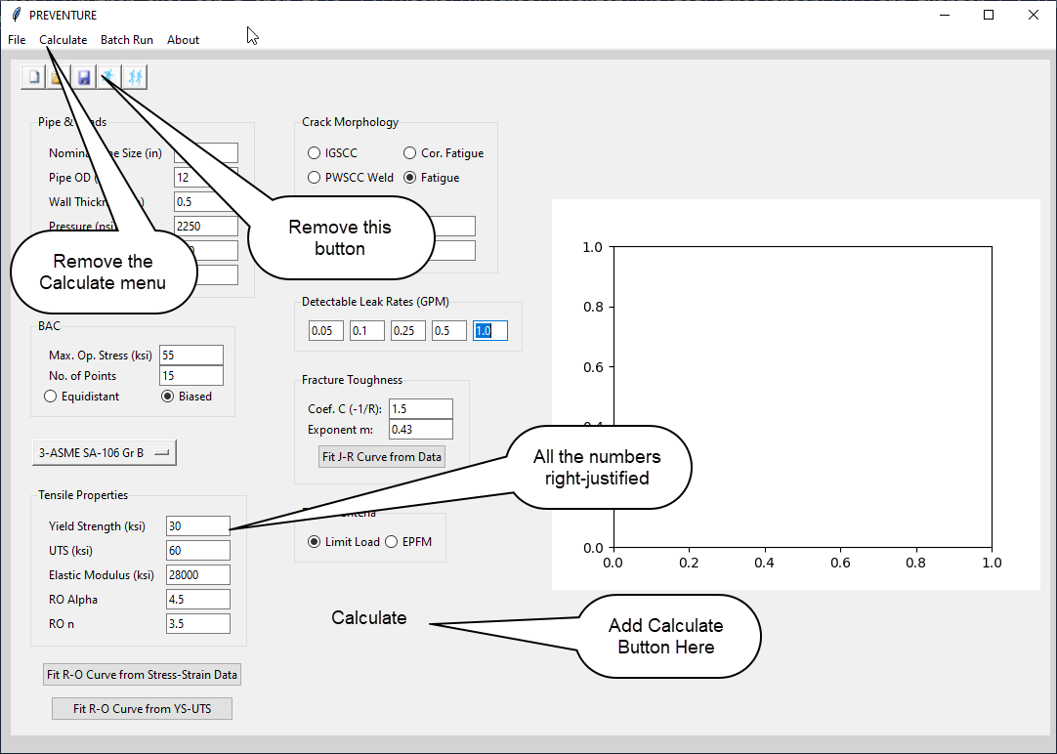

2. File/Open Analysis

Will open a file open dialog box. The user will enter a filename (for example, 1.jsn). Read all the data from the file and display it in the UI. Look for a smart way to read the JSON file and associate the values to the widgets in the UI.

2. File/Save Inputs

Will save the current inputs to the currently opened file. If a file was not opened, the user will be prompted to provide a name of the file where to save. If the user selects an existing file, overwrite warning will be given.

3. File/Save Input As

The user will be prompted to provide a name of the file where to save. If the user selects an existing file, overwrite warning will be given.

4. File/Save Output

Will save the current output to the current file. If a file was not opened, the user will be prompted to provide a name of the file where to save. If the user selects an existing file, overwrite warning will be given. This menu will be available only after the user has pressed the Calculate button.

5. File/Save Output As

The user will be prompted to provide a name of the file where to save. If the user selects an existing file, overwrite warning will be given. . This menu will be available only after the user has pressed the Calculate button.

6. File/Exit

Will close the application. If the input or the output files were not saved, it will give a warning.

7. Remove File/Close Analysis (no longer need this option)

8. These textboxes will be disabled if the material ID ≤9. Make this number a variable and define it at the top such that it can be easily changed.
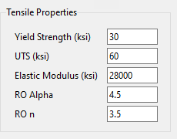

9. These textboxes and the buttons will be available only if the Material ID is 14. Make this number a variable and define it at the top such that it can be easily changed.
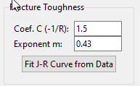

If material ID is 13, when the Fit J-R button is selected, you will bring up the module you had developed earlier. The resulting fitted values will be brought back into the above two text boxes.

10. These two buttons will be available only if the Material ID is ≥10. Make this number a variable and define it at the top such that it can be easily changed.
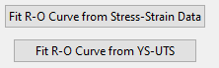
When Fit R-O Curve from Stress-Strain Data is selected, , you will bring up the module you had developed earlier. The resulting fitted values will be brought back into the above two text boxes (alpha and n)

11. The textboxes will be enabled only if “User-Defined” is selected.
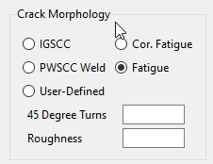

12. Remove this.
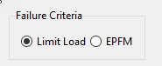
13. When Batch Run is selected from the menu bar, a dialog box is displayed.
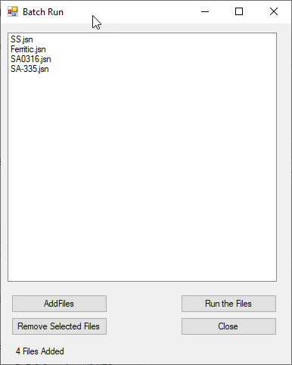

Add Files – will display a dialog box where the user can select one or more files.
Those files are displayed in the list. User can select and remove certain files.
Remove Files and Run the Files are only enabled after the user has selected one or more files.
(I will implement the logic for Run Files later)

14. When the Calculate button is pressed, the software will read a file like shown below and display a graph on the right hand side. The data will be in Excel File. I have attached the file.

The file will contain to a minimum columns A, B, G and H. It may have C, D, E and F also.
Base Metal
Leak Rate (GPM) | 0.05 (GPM) | 0.1 (GPM) | 0.25 (GPM) | 0.5 (GPM) | 1.0 (GPM)
Normal Stress (ksi) | Max. Stress (ksi) | Max. Stress (ksi) | Max. Stress (ksi) | Max. Stress (ksi) | Max. Stress (ksi) | Diagonal
3.212279 | 0 | 0 | 0 | 0 | 0 | 0 | 0
3.212279 | 30.1654 | 25.4779 | 18.44665 | 12.58728 | 9.071654 | 50 | 50
4.362808 | 32.50915 | 28.21228 | 21.57165 | 15.71228 | 11.02478
5.686524 | 34.8529 | 30.55603 | 24.30603 | 18.83728 | 12.58728
7.209498 | 36.80603 | 32.89978 | 27.0404 | 21.96228 | 15.71228
8.961723 | 38.75915 | 35.24353 | 29.77478 | 24.69665 | 18.83728
10.97771 | 40.32165 | 37.19665 | 32.11853 | 27.43103 | 21.96228
13.29716 | 41.88415 | 39.14978 | 34.46228 | 30.1654 | 25.08728
15.96575 | 43.05603 | 41.1029 | 36.80603 | 32.89978 | 28.21228
19.03604 | 44.61853 | 42.6654 | 39.14978 | 35.24353 | 31.33728
22.5685 | 45.39978 | 43.83728 | 41.1029 | 37.9779 | 34.07165
26.6327 | 46.18103 | 45.00915 | 43.05603 | 40.32165 | 36.80603
31.30868 | 46.96228 | 46.18103 | 44.2279 | 42.27478 | 39.5404
36.68852 | 47.74353 | 46.96228 | 45.39978 | 43.83728 | 41.49353
42.87819 | 48.13415 | 47.74353 | 46.18103 | 45.00915 | 43.05603
49.99957 | 48.52478 | 48.13415 | 46.96228 | 46.18103 | 44.61853
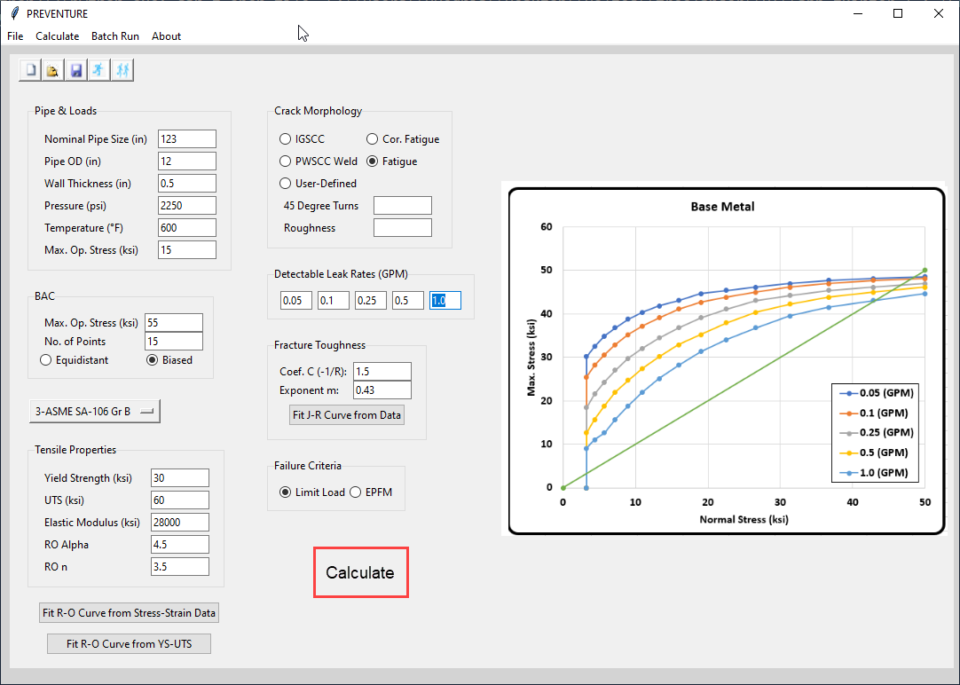
15. Materials List contains the following items.
1. ASME SA-312 BM/TIG
2. ASME SA-312, 304 Weld
3. ASME SA-312, 304L Weld
4. ASME SA-106 Gr B (Base Metal)
5. ASME SA-106 Gr C (Base Metal)
6. ASME SA-335. Gr P11 (Base Metal)
7. ASME SA-106 Gr B (Weld Metal)
8. ASME SA-106 Gr C (Weld Metal)
9. ASME SA-335. Gr P11 (Weld Metal)
10. Limit Load
11. Austenitic C-6330
12. Ferritic C-6331-1 Cat 1
13. Ferritic C-6331-1 Cat 2
14. EPFM (J-Based)

16. Validate Inputs
When the Calculate button is pressed, all the inputs should be validated based on the limits described in Inputs class. Only if all the inputs are valid, the chart is displayed. Otherwise the user will have to fix the inputs and press calculate again. I will provide and valid and invalid input files.

17. Link the inputs to the Inputs object and return that object when Calculate button is selected. Also, when the input file needs to be saved, do it in an efficient way by deserializing the object.
19. Redo the R-O Fit and the J-R fit dialog boxes that you developed in tkinter.
20. Note that this will require a few iterations.

